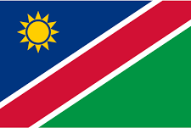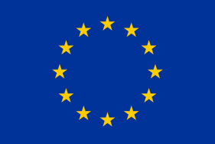
Press Release

On the Official Launch of Namibia’s Trade Information Portal,

10.00 am. 6 March 2024
Windhoek

1 Start Go live. https://namibiatradeportal.gov.na/

The Ministry of Industrialisation and Trade is proud to officially launch Namibia’s trade information portal which goes live today at 10.00 am the 6th of March 2025 at the Hilton Hotel in Windhoek. The trade portal was developed over two years with support from the European Union. It is a one-stop virtual shop providing in a single integrated website comprehensive up-to-date regulatory trade related information for import and export to facilitate trade activities. The portal is designed to help business operators especially small and medium-sized businesses to quickly and easily find the information necessary for exporting, transporting and importing products. The portal is in line with Namibia’s commitments under WTO Trade Facilitation Agreement to enhance the transparency and efficiency of trade processes, reduce barriers to trade, and promote Namibia as a competitive and attractive destination for trade and investment.
The 2-hour TIP official launch program will include the following
- Opening remarks followed by Namibia’s National and AU Anthems
- Presentation on TIP Objectives, Content, Governance Issues and Trends
- Keynote Address & Official Launch go live of the TIP
- TIP Demonstration -offering hands-on experiences with navigating the TIP followed by allowing attendees to login into TIP and observe its benefits first-hand
- Open engagement/questions and answers: MIT/TIP TWG members and Consultants will provide clarifications to any issues on TIP functions trends and opportunities
- TIP Networking and sharing ideas

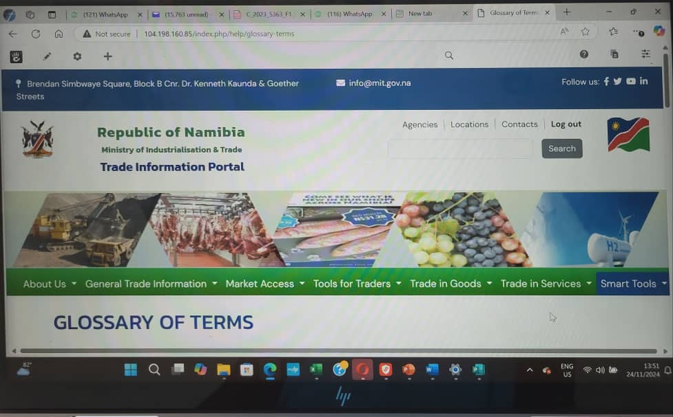

2 What does the Portal offer?
The trade portal offers a wide range of resources, including:
- Namibia trade profile, statistics and investment opportunities
- General export, import and transit procedures, including all trade related legislation, measures, procedures, forms and fees which can be searched by commodity of interest
- Information on instruments for facilitating cross-border trade
- Agriculture and mining trade regulations and procedures
- Requirements for second-hand motor vehicles imported from abroad
- Market access conditions under various bilateral and regional trade agreements Namibia is signed (SACU, SADC, COMESA-EAC-SADC Tripartite FTA, African Continental FTA, EU-SADC EPA, UK - SACU and Mozambique EPA, SACU European Free Trade Association Agreement, SACU - MERCUSOR Southern Common Market of the South Agreement, Namibia and USA African Growth and Opportunity Act)
- Various trade tools including, eTariff - duty estimator, online mechanism for addressing NTBs, rules of origins sanitary, phytosanitary, standards and other technical requirements in Namibia's main regional trade agreements,
- Namibia trade in services commitments under the WTO, AfCFTA and SADC
- Various smart tools such as Namibia trade fairs calendar, market research and intelligence tools, trade statistics sources, Namibia trade directories, useful trade related links, glossary of trade terms and FAQs

3. Advantages of the Trade Portal for businesses

The portal has various advantages for local and foreign business operators.
- It’s a user friendly online platform that can be accessed from anywhere with an internet connection
- Its cost saving as it reducing the number of trips or time required to obtain information.
- Its convenience as operators can quickly and easily find the information needed to export, transport and import products.
- It significantly improves Namibia’s business environment and attracts investors.
- By providing transparency in cross-border trade procedures, it makes it easier for businesses to navigate the regulatory environment on trade.

4 A wide attendance is expected

The TIP was developed as a national project involving all OMAs responsible for trade matters. The trade portal go live event will be officiated by Hon Deputy Minister of MIT. The Ambassador of the EU Delegation to Namibia, representatives and Heads of Missions of France Finland, Germany and Spain in Namibia, officials from the 22 OMAs that are members of the TIP technical working group, captains of industry, academia and NGOs will be in attendance. The event will also be open for interested parties to attend virtually

The portal is benchmarked to the best regional and international trade portals. It has several advanced features compared to similar portals of Namibia’s neighbouring countries

END

